SIMATS ENGINEERING (SAVEETHA SCHOOL OF ENGINEERING)
Department of Computer Science and Engineering
ASSESSMENT TOOL 1 – Coding Challenge Task
Course Code: | CSA06 | Course Title: | Design and Analysis of Algorithms
CO Assessed: | CO4: Articulation (BL4, BL5) | Assessment: | Assessment Tool 1 – Coding Challenge Task
Weightage: | 40% of CIA | Total Marks: | 100 (2 Questions × 50 Marks)
CO4 Statement: | Solve optimization problems using dynamic programming and greedy strategies.
Student Name: | MOHAMMED THOUSIF A | Reg. No.: | 192424093
Section / Batch: | AI/DS | Date:

Instructions to Students
- Answer both questions. Each question carries 50 Marks. Total: 100 Marks.
- Carefully analyze the given questions.
- Write clear code for the given problem.
- Analyze the Time complexity and Space complexity of your code using dynamic programming and greedy strategies

Question Type | Description | Questions | Total Marks
Coding Challenge Task | Focus on Code and analyze optimization problems using dynamic programming and greedy strategies | Q1 – Q2 | 100

SECTION A – Coding Challenge Task

Q44. Count Subsets with Given Sum
Given an array of integers and a target sum, count the number of subsets whose sum equals the given value. Each element can either be included or excluded. The goal is to find all possible valid subsets. Use Dynamic Programming to compute the count efficiently.
Input Format:
n = number of elements
arr[] = elements
sum = target
Sample Input:
n = 4
arr = 1 2 3 3
sum = 6
Expected Output:
Count = 3

Q45.Longest Repeating Subsequence
Given a string, find the length of the longest subsequence that appears at least twice without overlapping the same character index. The subsequences must be identical but originate from different positions. The goal is to identify the maximum repeating length. Use Dynamic Programming to compute efficiently.
Input Format:
s = input string
Sample Input:
s = AABEBCDD
Expected Output:
Length = 3

Code of Conduct
I ___________ (Name / Reg No) certify that this submission is my original work and that I have adhered to the guidelines specified for this assessment. I understand that any violation of academic integrity rules will result in disciplinary action.

Signature of the Student: _________________________

RUBRICS FOR CALCULATION
Coding Challenge Task

Criteria | Weightage | Level 4 (Exemplary) | Level 3 (Proficient) | Level 2 (Developing) | Level 1 (Beginning)
Problem Understanding | 20% | Clearly understands problem constraints, edge cases, and competitive requirements | Understands problem with minor gaps in constraints | Partial understanding; misses key constraints | Misinterprets problem or constraints
Algorithm | 25% | Selects optimal algorithm with best time and space complexity for competitive constraints | Uses efficient algorithm with minor scope for improvement | Uses basic/inefficient approach | No clear algorithmic approach
Code Implementation | 20% | Writes correct, efficient, and clean code that passes all constraints | Code works with minor errors or inefficiencies | Partially correct code; fails for some cases | Code does not execute or gives incorrect results
Competitive Performance | 20% | Solves problem within time limits and handles large inputs effectively | Solves within acceptable time with minor delays | Struggles with time limits or larger inputs | Unable to solve within time constraints
Test Case Handling | 15% | Handles all test cases including edge and hidden cases | Handles most test cases | Misses important edge cases | Fails on multiple test cases

Mark Evaluation:
Questions | Problem Understanding (20) | Algorithm (25) | Code Implementation  (20) | Competitive Performance  (20) | Test Case Handling  (15) | Total Marks  (Each - 50)
Q1
Q2
Overall Total

Faculty In-charge | Course Coordinator | Head of Department
Name: __________________  Signature: _______________ | Signature: _______________ | Signature: _______________
Date: ___________________ | Date: ___________________ | Date: ___________________

Q44. Count Subsets with Given Sum
Aim
To find the number of subsets in a given array whose sum is equal to a specified target value using Dynamic Programming.

Algorithm
- Read the number of elements n, the array arr[], and the target sum sum.
- Create a DP table dp[n+1][sum+1].
- Initialize:
  - dp[i][0] = 1 for all i (empty subset gives sum 0).
  - dp[0][j] = 0 for all j > 0.
- For each element:
  - If arr[i-1] <= j,
dp[i][j] = dp[i-1][j] + dp[i-1][j-arr[i-1]]
  - Else,
dp[i][j] = dp[i-1][j]
- The answer is stored in dp[n][sum].
- Display the count.

Code
def count_subsets(arr, target):
n = len(arr)

dp = [[0 for _ in range(target + 1)] for _ in range(n + 1)]

for i in range(n + 1):
dp[i][0] = 1

for i in range(1, n + 1):
for j in range(target + 1):
if arr[i - 1] <= j:
dp[i][j] = dp[i - 1][j] + dp[i - 1][j - arr[i - 1]]
else:
dp[i][j] = dp[i - 1][j]

return dp[n][target]

arr = [1, 2, 3, 3]
target = 6

print("Count =", count_subsets(arr, target))

Output
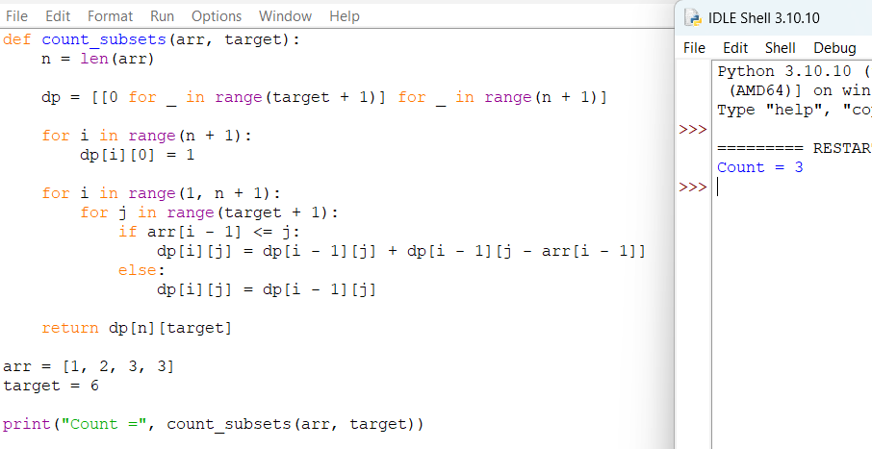

Result
Thus, the number of subsets whose sum equals the target value (6) is 3 using Dynamic Programming.

Q45. Longest Repeating Subsequence
Aim
To find the length of the longest repeating subsequence in a string using Dynamic Programming.

Algorithm
- Read the input string s.
- Let n be the length of the string.
- Create a DP table dp[n+1][n+1].
- Compare the string with itself.
- For each pair (i, j):
  - If s[i-1] == s[j-1] and i != j,
dp[i][j] = 1 + dp[i-1][j-1]
  - Else,
dp[i][j] = max(dp[i-1][j], dp[i][j-1])
- The value dp[n][n] gives the length of the longest repeating subsequence.
- Display the result.

Code
def longest_repeating_subsequence(s):
n = len(s)
dp = [[0 for _ in range(n + 1)] for _ in range(n + 1)]
for i in range(1, n + 1):
for j in range(1, n + 1):
if s[i - 1] == s[j - 1] and i != j:
dp[i][j] = 1 + dp[i - 1][j - 1]
else:
dp[i][j] = max(dp[i - 1][j], dp[i][j - 1])
return dp[n][n]
s = "AABEBCDD"
print("Length =", longest_repeating_subsequence(s))

Output
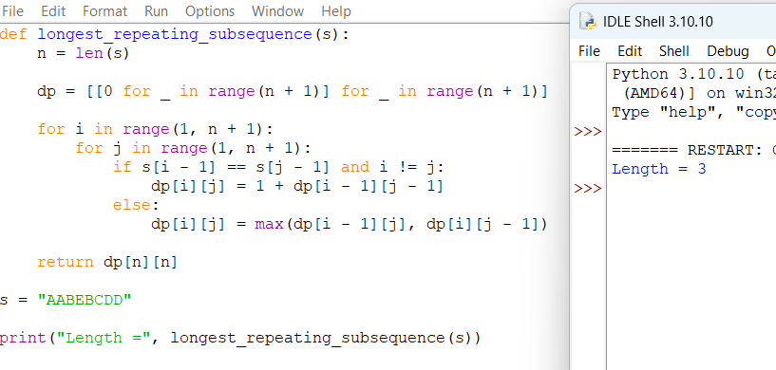

Result
Thus, the length of the longest repeating subsequence in the string "AABEBCDD" is 3 using Dynamic Programming.

